Attendance Recovery Computation
1. Problem Statement
Write a Python program to calculate attendance percentage and find the minimum classes required to reach the eligibility percentage.
2. Assumptions
- Total classes must be greater than zero.
- Attended classes cannot exceed conducted classes.
- Eligibility percentage is entered by the user.
3. Algorithm
- Start.
- Read attended and conducted classes.
- Read eligibility percentage.
- Validate attendance details.
- Calculate current attendance.
- Find required classes using a while loop.
- Calculate future attendance.
- Display eligibility result.
- Stop.
4. Flowchart
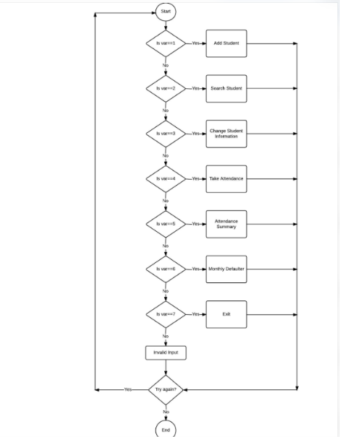
5. Pseudocode
START
INPUT attended, conducted, threshold

IF conducted <= 0 OR attended < 0
OR attended > conducted
DISPLAY "Invalid attendance details"
ELSE
percentage = attended / conducted * 100

IF percentage >= threshold
DISPLAY "Already eligible"
ELSE
required = 0
WHILE attendance < threshold
required = required + 1
END WHILE

DISPLAY required
INPUT future
CALCULATE future percentage
DISPLAY eligibility result
END IF
END IF
STOP
6. Output
Enter classes attended: 60
Enter total classes conducted: 100
Enter eligibility percentage: 75

Current Attendance: 60.0 %
Minimum consecutive classes required: 60
Enter additional classes you may attend: 60
Future Attendance: 75.0 %
Eligibility achieved.
7. Conclusion
The program calculates attendance percentage and finds the required classes to achieve eligibility.

